
Membership Application Form

Title: Mr/Mrs/Miss/Ms Date of Birth:
/ /

First Name: Surname:

Address:

Post Code: Tel:

Email:

Membership Password:
If you have an email address, please create a password. This will be used as your login details to access the members section of the website. (Between 8-15 characters, including both an upper-case letter and a number)
Where did you hear about us?:

Payment Details

Please select your preferred payment by crossing the box of your selection.

Online Membership £24 Credit/Debit Card Paper Membership £34 Cheque (Please make cheques payable to ‘The IBS Network’)
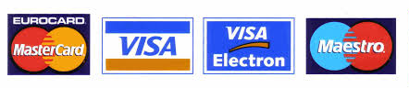
Card Holders Name:

Card Type: Card Number:
/ /
/ /
Start Date: Expiration Date:
Card Verification Number*:

Gift Aid**: I am a UK taxpayer and I would like to increase my donation by 25% under the Gift Aid Scheme. I want The IBS Network to treat all donations, until I notify otherwise, as Gift Aid donations.

